Directional SPX Calendar

Dan Sheridan SPX Sizing=1
Visionner l’enregistrement (gotowebinar.com)
Directional Calendars With Dan and Mark - www.sheridanmentoring.com

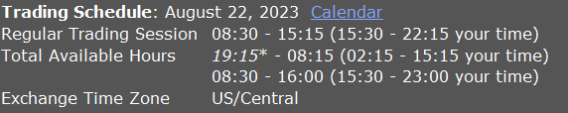

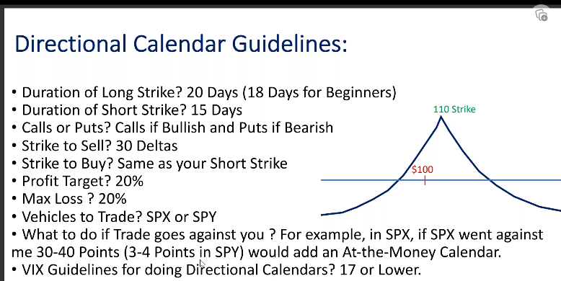
Put Calendar if goes down (for the Double calendar)
Call Calendar if goes up (for the Double calendar)
Put and Call walls to identify limits
If Put wall < Target -> DO not trade – same for Call wall > Target

